Project Report
Project Title | Implement Client Script & UI Policy (Incident)
Platform | ServiceNow (Personal Developer Instance)
Team ID | SWTID-2026-8273
Team Members | Naveen.R, Rudhran.S.N, Ramesh.M, Vivilian Joshua.A, Sarathi.S

1. INTRODUCTION

1.1 Project Overview
Incident Management is one of the most used processes in ServiceNow. The quality of an incident depends on the details entered in the Incident form, but users often skip important fields, enter very short descriptions or forget to add reasons when they put a ticket on hold. This project, Implement Client Script & UI Policy (Incident), uses the client-side features of ServiceNow to guide users while they fill the form. UI Policies control whether fields are mandatory, visible or read-only depending on the State and Priority of the incident, and Client Scripts (onLoad, onChange and onSubmit) display helpful messages and stop the submission of incomplete data. All of this runs in the browser, so users get instant feedback without waiting for the server.

1.2 Purpose
The purpose of the project is to improve the completeness and consistency of incident data and to reduce the effort spent on follow-up questions. The goals are:
- Make the Incident form dynamic, so that fields change according to the State, Priority and Category selected.
- Force users to provide a reason when an incident is put On Hold and resolution details when it is Resolved.
- Give instant on-screen guidance using field messages and information messages.
- Block the submission of Priority 1 incidents that do not have a proper description.
- Gain practical experience with UI Policies, Client Scripts and the g_form client API on a real ServiceNow instance.

2. IDEATION PHASE

2.1 Problem Statement
Incident tickets are frequently saved with missing or poor-quality information. Resolvers then have to contact the caller again, which delays the resolution and affects the service levels. The problem is described from the point of view of the two main users below.
 | PS-1 | PS-2
I am | a service desk agent who logs and updates incidents | a service desk manager who reviews incident quality
I am trying to | record complete and correct incident details quickly | make sure every incident has enough information to be resolved
But | the form lets me save without a hold reason, resolution notes or a proper description | many tickets arrive with very short or empty descriptions
Because | no rules guide me or stop me when a required field is left empty | fields are optional and there is no check at the time of saving
Which makes me feel | unsure and frustrated when the caller is contacted again | concerned about delays and poor service quality

2.2 Empathy Map Canvas
The empathy map below is for the primary user, the Service Desk Agent, who creates and updates incidents on the Incident form.
SAYS  • "I do not have time to fill every field."  • "Why was this ticket put on hold?"  • "The caller needs a quick update." | THINKS  • "I hope I have not missed anything."  • "A clear form would save me time."  • "Incomplete tickets make my work harder."
DOES  • Opens the Incident form and fills in the main fields  • Changes State, Impact and Urgency  • Calls the caller again for missing details | FEELS  • Pressured to close tickets quickly  • Frustrated by rework  • Confident when the form guides them
PAINS  • Missing hold reasons and resolution notes  • Very short descriptions on critical tickets  • No warning before saving wrong data | GAINS  • Clear mandatory fields at the right time  • Instant messages while typing  • Better quality tickets and faster resolution
Fig 2.2 Empathy Map Canvas - Service Desk Agent

2.3 Brainstorming
The team brainstormed ways to improve the Incident form using only client-side features. Each team member listed ideas, and the ideas were then grouped and prioritised by impact and effort.
Idea | Type | Impact | Effort | Decision
Make On hold reason mandatory when State is On Hold | UI Policy | High | Low | Selected
Make Resolution code and notes mandatory when State is Resolved | UI Policy | High | Low | Selected
Make Description mandatory for Priority 1 incidents | UI Policy | High | Low | Selected
Make key fields read-only for Closed incidents | UI Policy | Medium | Low | Selected
Show a guidance message when a new incident is opened | Client Script (onLoad) | Medium | Low | Selected
Show a field message when Category or Impact changes | Client Script (onChange) | Medium | Low | Selected
Block submit of P1 incident with short description | Client Script (onSubmit) | High | Medium | Selected
Auto-assign groups using GlideAjax | Client + Server | Medium | High | Future scope
Validate data from API and import sets | Data Policy / Business Rule | High | High | Future scope

3. REQUIREMENT ANALYSIS

3.1 Customer Journey Map
The journey map follows the agent from opening the Incident form to saving the record and shows how the solution improves each stage.
Stage | Agent Action | Pain Point (Before) | Experience | Improvement (After)
1. Open form | Clicks Incident > Create New | No guidance on what to fill | Neutral | onLoad script shows a guidance message
2. Enter details | Selects Category, Impact and Urgency | No help on choosing values | Unsure | onChange scripts show field messages
3. Change state | Sets State to On Hold or Resolved | Reason and notes are skipped | Rushed | UI Policies make the fields visible and mandatory
4. Submit | Clicks Submit or Save | Poor data saved for P1 tickets | Worried | onSubmit script blocks invalid data with a message
5. Review | Re-opens a closed incident | Closed records can be edited by mistake | Frustrated | UI Policy makes key fields read-only

3.2 Solution Requirement
Functional Requirements
FR No. | Functional Requirement | Sub Requirement
FR-1 | On hold handling | When State is On Hold, show On hold reason and make it mandatory
FR-2 | Resolution handling | When State is Resolved, make Resolution code and Resolution notes mandatory
FR-3 | Critical incident details | When Priority is 1 - Critical, make Description mandatory
FR-4 | Closed incident protection | When State is Closed, make key fields read-only
FR-5 | New incident guidance | Show an information message when a new incident form loads
FR-6 | Dynamic field messages | Show messages when Category or Impact values change
FR-7 | Submit validation | Stop submit if a P1 incident has a description shorter than 20 characters

Non-functional Requirements
NFR No. | Non-functional Requirement | Description
NFR-1 | Usability | Messages must be short and clear so that agents understand them at once
NFR-2 | Performance | Scripts must run instantly and must not slow the form load noticeably
NFR-3 | Reliability | UI Policies must reverse when the condition is no longer true
NFR-4 | Maintainability | Scripts must be simple, commented and captured in an Update Set
NFR-5 | Security | Access is controlled by roles and ACLs; client checks are only for usability

3.3 Data Flow Diagram
The diagram shows how data moves between the agent, the client-side logic and the Incident table.
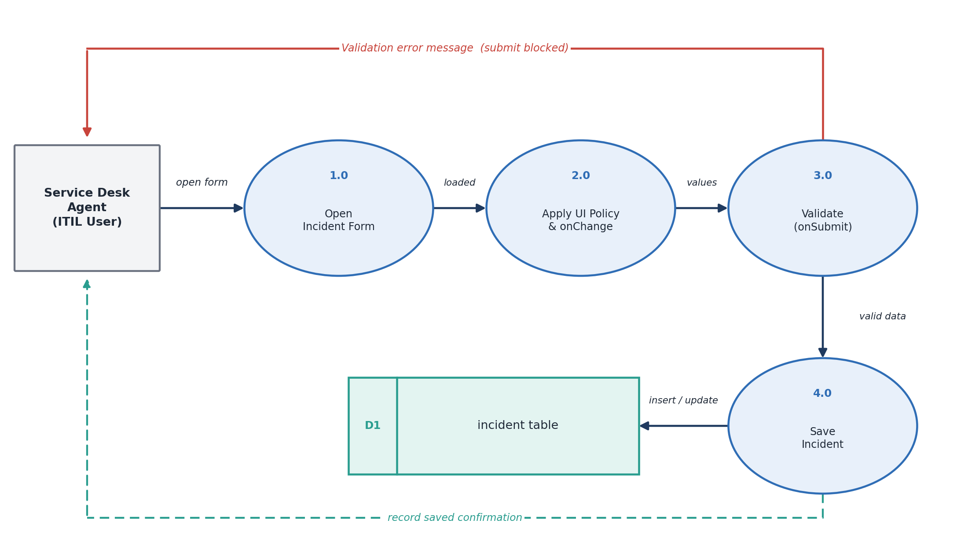
Fig 3.3 Data Flow Diagram (Level 1) - Incident form with UI Policy and Client Scripts

3.4 Technology Stack
Component | Technology / Tool
Platform | ServiceNow (Personal Developer Instance from developer.servicenow.com)
Client-side logic | UI Policies and Client Scripts (onLoad, onChange, onSubmit)
Scripting language | JavaScript using the g_form and g_user client APIs
Data | Incident table (extends Task table)
Server layer | Glide platform, ACLs, Table API (used for reference only)
Deployment / Tracking | Local Update Set
Testing tools | Incident form, JavaScript Log and Field Watcher, browser Developer Tools
Browser | Google Chrome / Microsoft Edge

4. PROJECT DESIGN

4.1 Problem Solution Fit
Problem | Solution | Fit
Hold reason is missing on on-hold tickets | UI Policy: On hold reason visible and mandatory | Every on-hold ticket has a reason
Resolved tickets have no resolution details | UI Policy: Resolution code and notes mandatory | Complete closure information
Critical tickets have poor descriptions | UI Policy and onSubmit script for Priority 1 | Enough detail for fast action
Users get no guidance while filling the form | onLoad and onChange Client Scripts | Faster and more accurate entry
Closed tickets can be edited by mistake | UI Policy: read-only fields | Closed records stay reliable

4.2 Proposed Solution
The proposed solution configures four UI Policies and four Client Scripts on the Incident table. UI Policies handle the field behaviour that depends on conditions, and Client Scripts handle messages and validation that need logic. The solution is simple and needs no server-side code or extra plugins, so it is easy to maintain and can be moved to other instances with an Update Set. The flow of the solution is shown below.
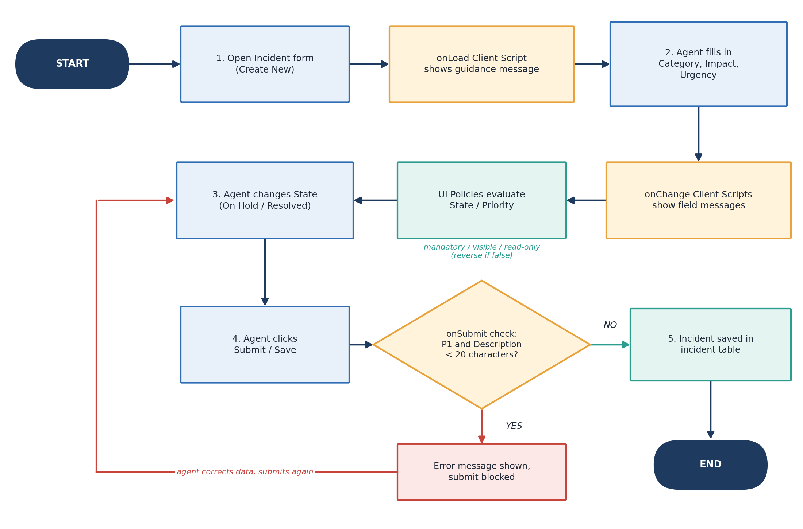
Fig 4.2 Workflow of the proposed solution
UI Policies
ID | Short Description | Condition | UI Policy Actions
UP-1 | Incident - On Hold Reason | State is On Hold | On hold reason: Visible = true, Mandatory = true
UP-2 | Incident - Resolution Details | State is Resolved | Resolution code: Mandatory; Resolution notes: Mandatory
UP-3 | Incident - P1 Description | Priority is 1 - Critical | Description: Mandatory
UP-4 | Incident - Closed Read-only | State is Closed | Short description, Category, Description: Read only
All UI Policies have Active, On load and Reverse if false selected, so the form returns to normal when the condition is no longer true.
Client Scripts
ID | Name | Type | Field | Purpose
CS-1 | Incident - Welcome Message | onLoad | - | Guidance message for new incidents
CS-2 | Incident - Category Guidance | onChange | Category | Field message on Subcategory for Hardware
CS-3 | Incident - High Impact Message | onChange | Impact | Reminder to describe business impact
CS-4 | Incident - P1 Description Check | onSubmit | - | Block submit if P1 description is under 20 characters

4.3 Solution Architecture
The solution follows the standard ServiceNow layered architecture. The user works in the browser on the Incident form. The UI Policies and Client Scripts form the client-side logic layer, and the validated record is then saved by the server layer in the incident table.
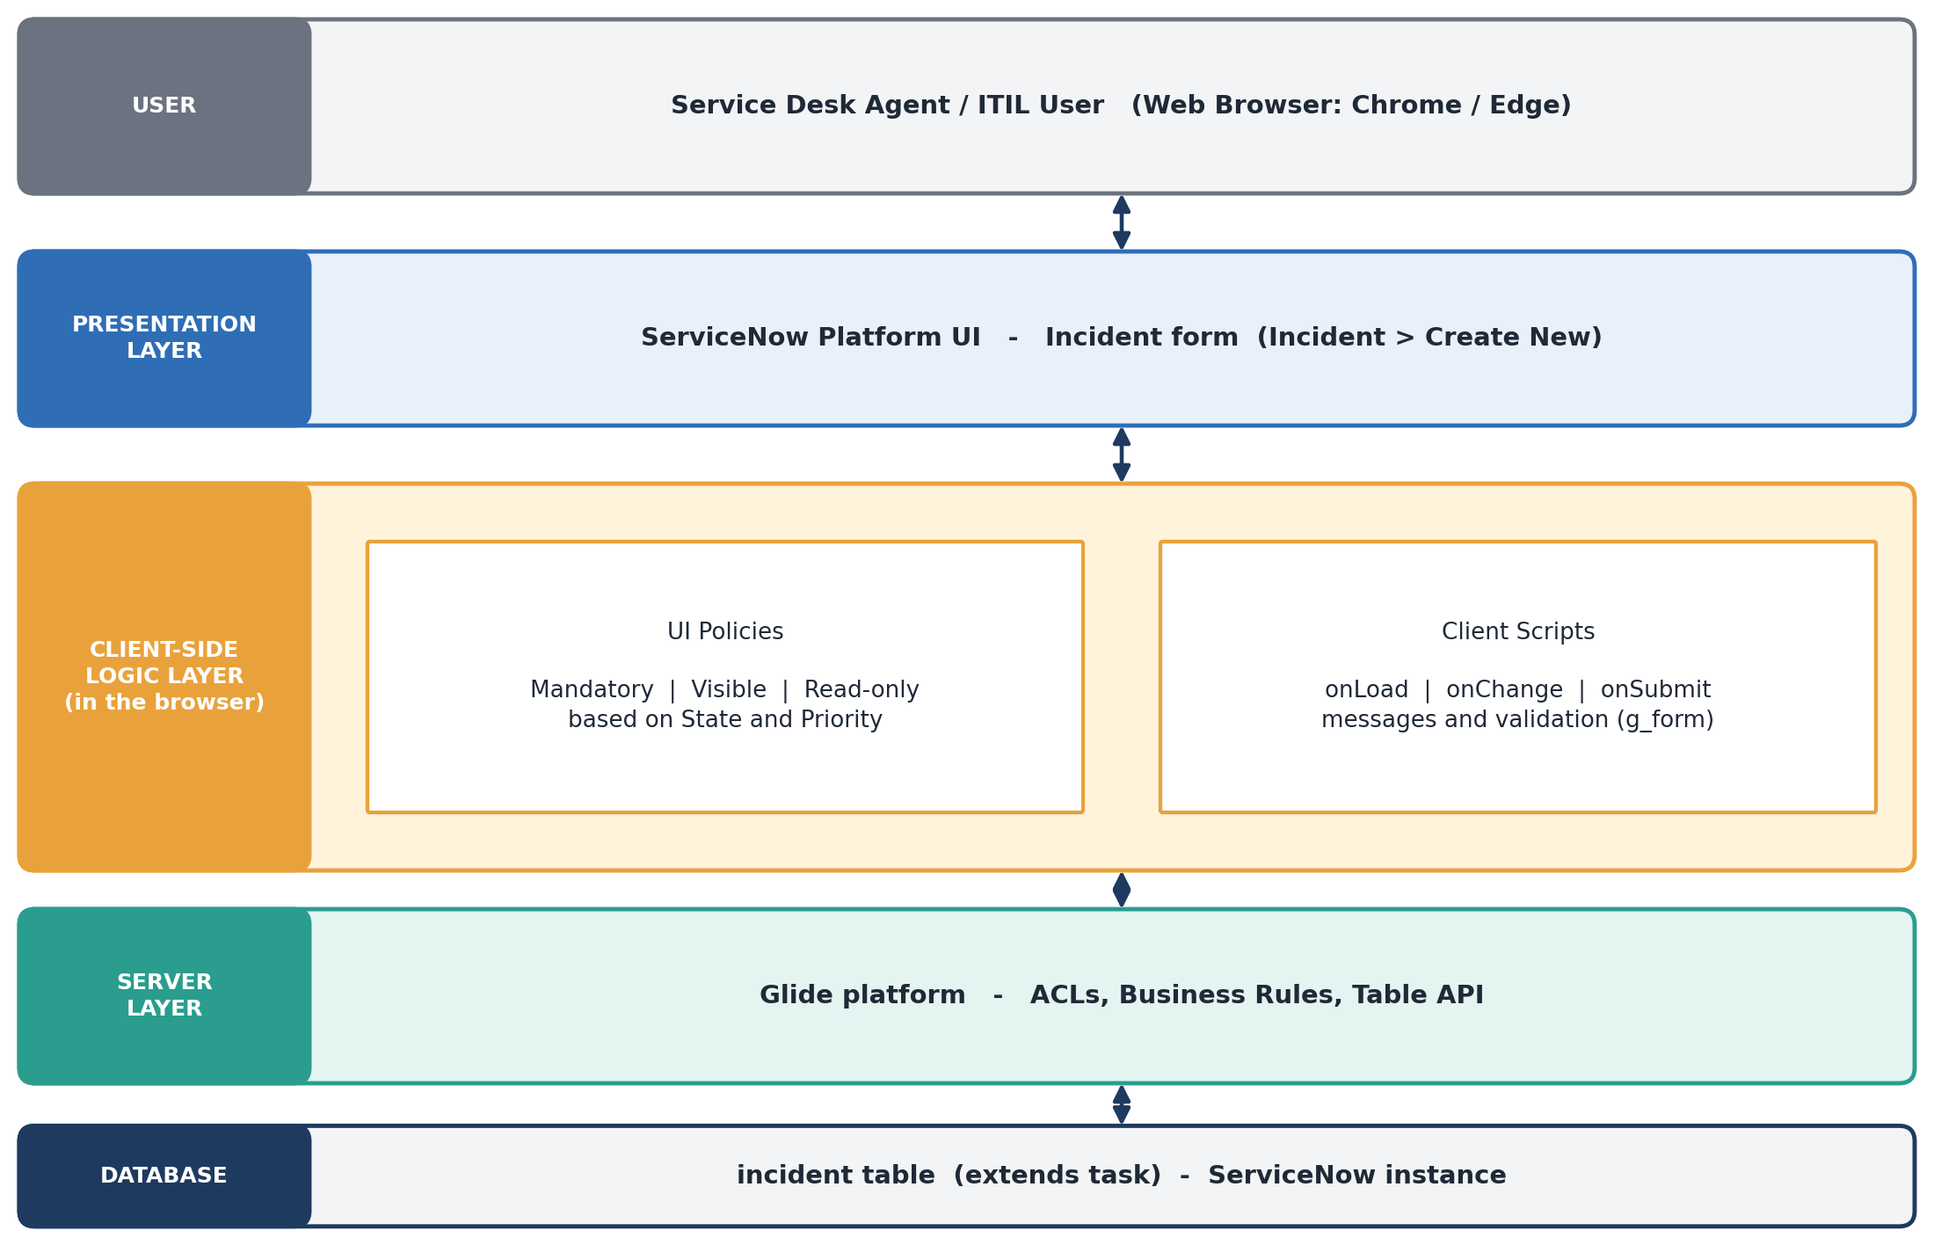
Fig 4.3 Solution Architecture

5. PROJECT PLANNING & SCHEDULING

5.1 Project Planning
The project was planned in phases, and the work was divided among the five team members as shown below.
Phase | Activity | Team Member(s) | Deliverable
1 | Project kick-off, problem statement, empathy map and brainstorming | All members | Ideation phase
2 | Requirement analysis, journey map, PDI setup and Update Set creation | Naveen.R, Sarathi.S | Requirements, working instance
3 | Solution design and configuration of the four UI Policies | Naveen.R, Vivilian Joshua.A | UI Policies UP-1 to UP-4
4 | Development of the four Client Scripts | Rudhran.S.N | Client Scripts CS-1 to CS-4
5 | Functional and performance testing, bug fixing and screenshots | Ramesh.M, All members | Test results, screenshots
6 | Final report, FSD documentation, Update Set export and demo | Vivilian Joshua.A, Sarathi.S | Final report and demo

6. FUNCTIONAL AND PERFORMANCE TESTING

6.1 Performance Testing
Each UI Policy and Client Script was tested on the Incident form with a positive case and a negative case. The test cases, expected results and performance checks are given below. The Status column is filled in after the test is executed.
Functional Test Cases
ID | Test Scenario | Steps / Input | Expected Result | Status
TC-1 | Welcome message | Open Incident > Create New | Information message is displayed on the form | Pass / Fail
TC-2 | On Hold reason | Set State = On Hold | On hold reason appears and is mandatory; save is blocked if empty | Pass / Fail
TC-3 | Reverse UI Policy | Change State from On Hold to In Progress | On hold reason is hidden and no longer mandatory | Pass / Fail
TC-4 | Resolution details | Set State = Resolved | Resolution code and notes are mandatory | Pass / Fail
TC-5 | P1 description mandatory | Set Impact = 1 and Urgency = 1 (Priority 1) | Description becomes mandatory | Pass / Fail
TC-6 | Category message | Set Category = Hardware | Field message appears on Subcategory | Pass / Fail
TC-7 | Impact message | Set Impact = 1 - High | Field message appears on Impact | Pass / Fail
TC-8 | Submit validation (negative) | P1 incident with description of 5 characters, click Submit | Submit is blocked with an error message | Pass / Fail
TC-9 | Submit validation (positive) | P1 incident with description of 30 characters, click Submit | Incident is saved successfully | Pass / Fail
TC-10 | Closed incident | Open an incident with State = Closed | Short description, Category and Description are read-only | Pass / Fail

Performance Checks
Check | Method | Target | Measured
Incident form load time | Browser Developer Tools (Network tab) or Client Transaction Timings | No noticeable increase with scripts active | ____ sec
onChange response time | Change Category / Impact and observe the message | Message appears instantly (under 1 second) | ____ sec
onSubmit validation time | Click Submit with invalid data | Error shown instantly without a server call | ____ sec
Browser console errors | Developer Tools (Console) and JavaScript Log | No JavaScript errors | Yes / No

7. RESULTS

7.1 Output Screenshots
The screenshots below show the UI Policy configured on the Incident table in the ServiceNow instance.
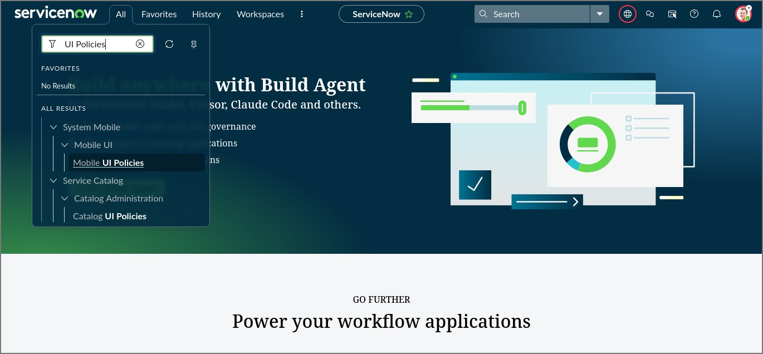
Fig 7.1 Opening UI Policies from the Application Navigator (All > UI Policies)
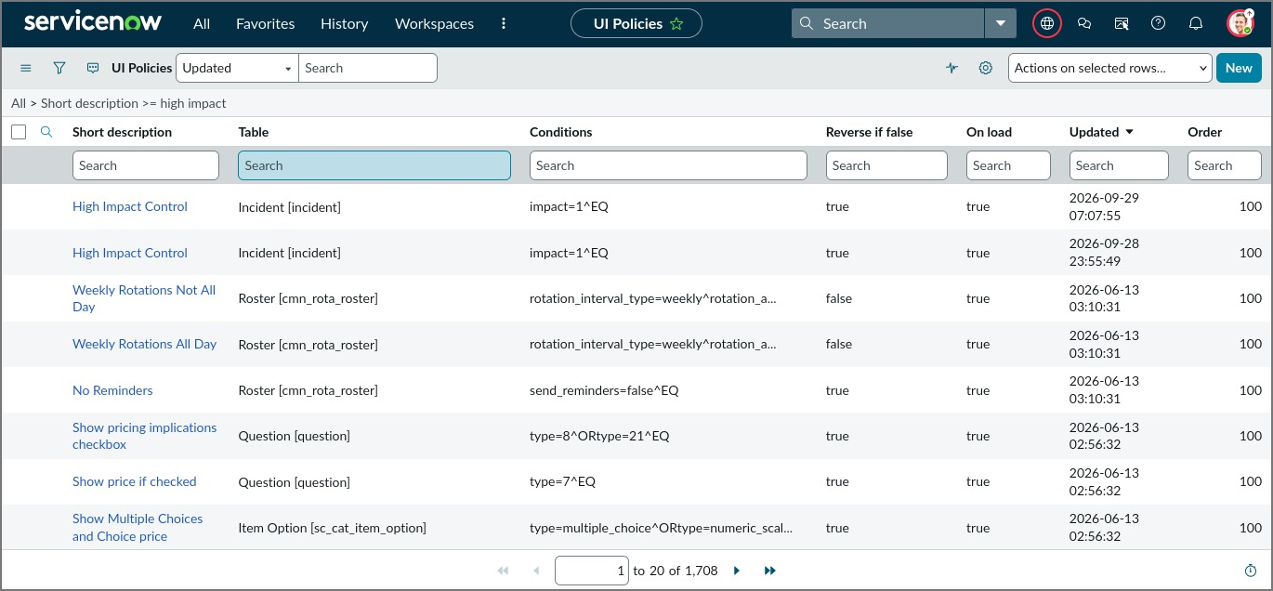
Fig 7.2 UI Policies list filtered for "high impact" on the Incident table
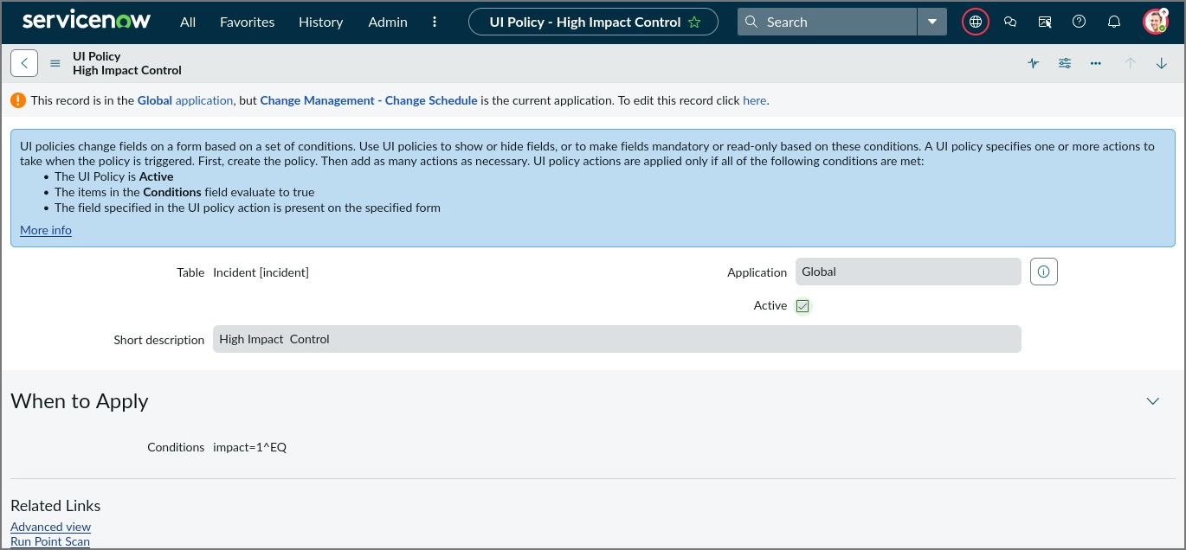
Fig 7.3 UI Policy "High Impact Control" on the Incident table with condition impact = 1
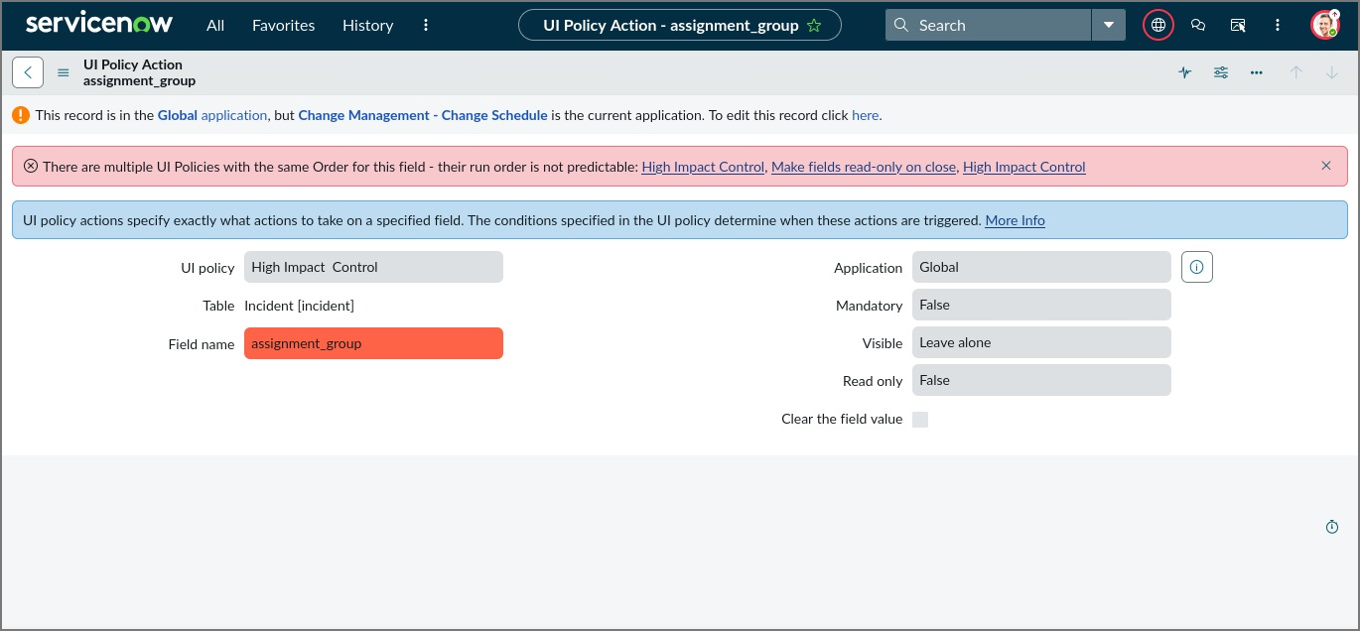
Fig 7.4 UI Policy Action for the assignment_group field of "High Impact Control"

8. ADVANTAGES & DISADVANTAGES
Advantages | Disadvantages
- Better quality and completeness of incident data.  - Instant feedback in the browser without a server call.  - Simple to build with low-code configuration.  - Fewer follow-up calls and faster resolution.  - Easy to move between instances using an Update Set.  - Reversible UI Policies keep the form clean. | - Runs only in the browser UI, not for API, import or background updates.  - Can be bypassed by technical users, so server-side rules are still needed.  - Too many client scripts can slow down form loading.  - Needs separate handling for Workspace and mobile views.  - Rules are fixed for the Incident table only.  - Does not replace ACLs and Business Rules.

9. CONCLUSION
The project successfully implemented four UI Policies and four Client Scripts on the Incident form of ServiceNow. The form now behaves dynamically: it asks for a hold reason when a ticket is put on hold, asks for resolution details when a ticket is resolved, protects closed records and stops Priority 1 incidents from being saved with a poor description. Users also receive clear messages while they work. The project helped the team understand the difference between UI Policies and Client Scripts, the use of the g_form API, and the importance of tracking changes in Update Sets. The work shows that simple client-side configuration can improve data quality with very little effort.

10. FUTURE SCOPE
- Add server-side Data Policies and Business Rules so that the same checks apply to API, import set and background updates.
- Extend the approach to Problem, Change Request and Service Catalog forms.
- Use Script Includes with GlideAjax for dynamic validation and auto-filling values from other tables.
- Configure the rules for Service Operations Workspace and the mobile application.
- Package the work as a scoped application and add Automated Test Framework (ATF) tests.

11. APPENDIX

Source Code (if any)
Client Script source code used in the project (UI Policies are configured through the form and do not need script).
// CS-1 onLoad | Table: Incident | Name: Incident - Welcome Message
function onLoad() {
if (g_form.isNewRecord()) {
g_form.addInfoMessage(
'Please provide complete details: caller, category, impact and urgency.');
}
}

// CS-2 onChange | Field: Category | Name: Incident - Category Guidance
function onChange(control, oldValue, newValue, isLoading, isTemplate) {
if (isLoading || newValue === '') { return; }
g_form.hideFieldMsg('subcategory');
if (newValue == 'hardware') {
g_form.showFieldMsg('subcategory', 'Select the type of hardware issue.', 'info');
}
}

// CS-3 onChange | Field: Impact | Name: Incident - High Impact Message
function onChange(control, oldValue, newValue, isLoading, isTemplate) {
if (isLoading || newValue === '') { return; }
if (newValue == '1') {
g_form.showFieldMsg('impact',
'High impact: describe the business impact in the Description.', 'info');
} else {
g_form.hideFieldMsg('impact');
}
}

// CS-4 onSubmit | Table: Incident | Name: Incident - P1 Description Check
function onSubmit() {
var priority = g_form.getValue('priority');
var description = g_form.getValue('description');
if (priority == '1' && description.trim().length < 20) {
g_form.addErrorMessage(
'For a Priority 1 incident, Description must be at least 20 characters.');
g_form.showFieldMsg('description', 'Enter at least 20 characters.', 'error');
return false; // stop the submit
}
return true;
}

Dataset Link
Not applicable. The project uses the Incident table records created in the ServiceNow Personal Developer Instance and does not use an external dataset.

GitHub & Project Demo Link
GitHub Link | https://github.com/NaveenR6407/Implement-Client-Script-UI-Policy-Incident-
Project Demo Link | https://github.com/NaveenR6407/Implement-Client-Script-UI-Policy-Incident-/tree/main/Demo%20Video

